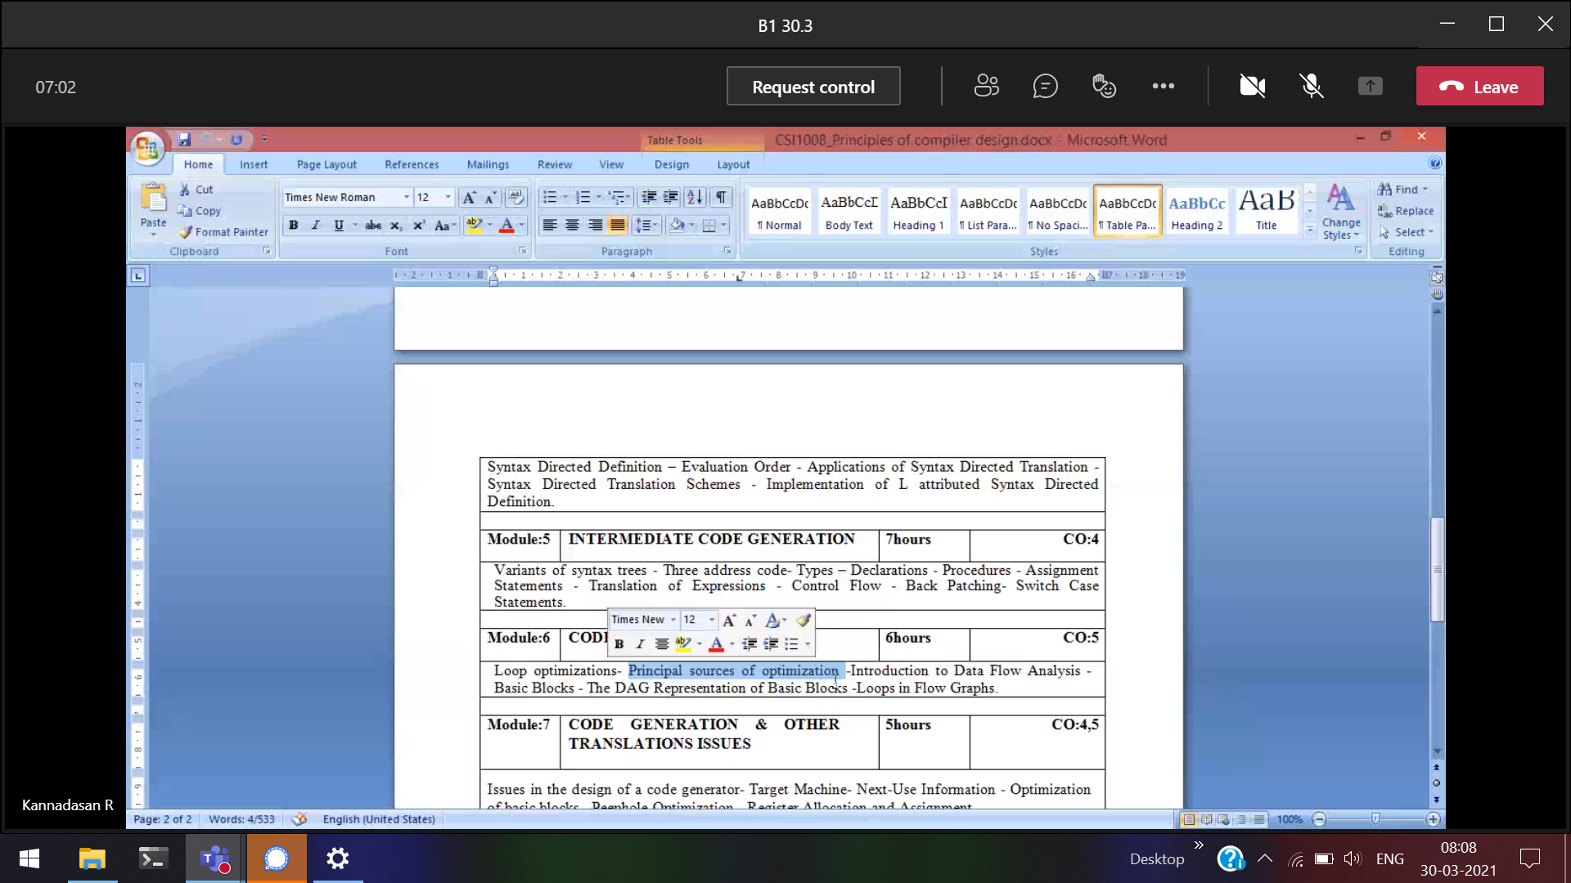



Three address code

Principal sources of optimization

The DAG Representation of Basic Blocks

Issues in the design of a code generator

Module-7

Important 10 mark